From parchment to 3D to HTML: the use of the 3D and the Web in architectural history research (a case study)

Dr. Bereczki Zoltán

# Background

In my PhD thesis defended in 2017 I attempted to reconstruct in 3D the process of a 15th-century tower construction, with the use of contemporary sources. [1] While creating the images for the final version of the thesis I faced the problem that the paper as a medium is only able to communicate fragments of the information contained by the model. This project is the result of this realisation.

# Methodology

One of the main questions of the research of the mediæval technical drawings is whether they served as a modern blueprint or not; so was their main purpose to make possible the realisation of a structure (machine, building), or something else (education, representation, etc). [2] [3] [4] The most reassuring way to answer this question would be conducting a lifesize experiment: to construct the structures relying only on the drawings representing them. Since there is hardly an opportunity to achieve this, 3D-modelling emerges as a solution. During my research I modelled the partially realised north tower of the Stephanskirche in Vienna using exclusively its contemporary (15th-century) plans: the floor plan and the elevation. I also created models of the machinery needed, based on contemporary machine drawings. I attempted to recreate the scaffoldings too, but due to the lack of contemporary sources for this task I used Early Modern and Modern Drawings too, but all of them are dated before the age of industrialisation.

In my thesis I represented the construction process in five main phases. Consequently, the on-line presentation consists of five subpages. The main content of each is the embedded WebGL-window with the model of that phase. Under it the list of the related contemporary sources can be found, and each machine and the scaffolding has also separate WebGL-windows.

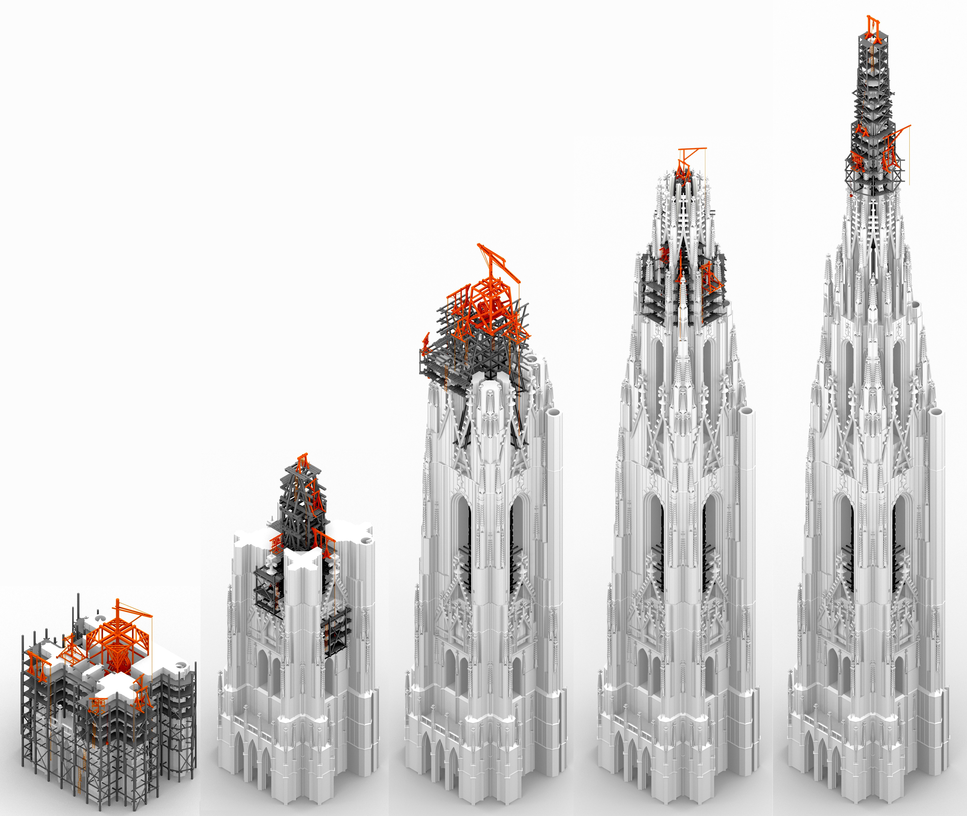

The five main phases

I think that plugin-free execution and version tracking are very important, so the models are presented in HTML5 (WebGL), and the project is powered by GitHub Pages.

# Results

The result is one side the model presenting the Gothic construction; on the other side its detailed online interpretation, where the intricate spatial structure can be observed interactively, in detail.

# Conclusions

The mediæval drawings used for the project are definitely workshop drawings, „blueprints”: relying on them and only them it was possible to build up in 3D both the complex building, both the elaborate machines. For the presentation the Web as a medium was much more appropriate than printing.

# Bibliography

[1] Z. Bereczki, “Gótikus tornyok építésének kérdéséhez. Mit mondanak a megvalósult épületek a tervezésről, mit mondanak a tervek a megvalósulásról?” Ph.D. értekezés, Pécsi Tudományegyetem, Műszaki és Informatikai Kar, Breuer Marcell Doktori Iskola, 2017.

[2] F. Bucher, “Design in Gothic Architecture: A Preliminary Assessment,” *Journal of the Society of Architectural Historians*, vol. 27, no. 1, pp. 49–71, 1968.

[3] W. Lefèvre, Ed., *Picturing machines 1400–1700*. Cambridge, Mass.: MIT Press, 2004.

[4] Z. Bereczki, “The machine drawings of Hans Hammer in the context of the contemporary machine representations,” *Pollack Periodica*, vol. 10, no. 3, pp. 165–174, Oct. 2015.